**Medications and Older Adult Abuse and Neglect**

Marty Eng, PharmD, RPh, CGP, CDP, BCPP, CADDCT, FASCP

Associate Professor, Department of Pharmacy Practice

Cedarville University – School of Pharmacy

**Learning Objectives**

* Define elder abuse/neglect/mistreatment.
* Describe how medication misuse might apply to abuse/neglect/mistreatment.
* List risk factors for abuse/neglect associated with medication management.
* List resources and measures to prevent abuse/neglect associated with medication misuse.

**Terminology**

* Abuse
  + “purposeful attempts by healthcare staff to inflict physical or emotional harm on patients.”
* Neglect
  + “the failure of a designated caregiver to meet the needs of a dependent”
* Mistreatment
  + WHO: “a single or repeated act or lack of appropriate action, occurring within any relationship where there is an expectation of trust, which causes harm or distress to an older person”
  + US NRCP to Review Risk and Prevalence of EA/Neglect: “intentional actions that cause harm or create a serious risk of harm to a vulnerable elder by a caregiver of other person who stands in a trust relationship to the elder OR failure by a caregiver to satisfy the elder’s basic needs or to protect the elder from harm.”

**Keys**

* Intent/purpose
* Harm
* Vulnerability

**TYPES OF ABUSE AND MEDICATIONS**

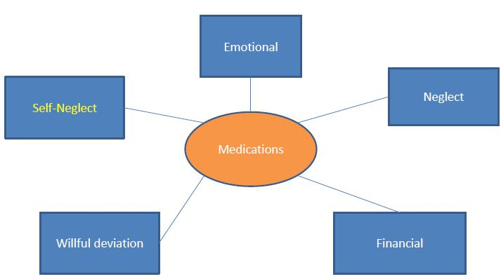

**Risk Factors – Older Adult**

* cognitive impairment
* behavioral problems
* psychiatric illness or psychological problems
* functional dependency
* poor physical health or frailty
* low income or wealth
* trauma
* past abuse
* ethnicity

**Other Risk Factors**

* Perpetrator
  + Caregiver burden or stress
  + Psychiatric illness or psychological problem
* Relationship
  + Family disharmony
  + Poor or conflictual relationships
* Environment
  + Low social support
  + Living with others (except for financial abuse)

**Possibly Related Factors**

* External system failures
* Workloads
* Crises
* Team failures
* Unintentional error
* Lack of a caring attitude towards patients.
* Complex Interaction of Multiple Factors

**Conclusions**

* Several keys to preventing abuse/neglect/mistreatment
* Community involvement
* Complex multifactorial issue
* Very gray area
* Culture: Dialogue and educate

**Resources**

* <http://www.ncea.aoa.gov/Stop_Abuse/Get_Help/State/index.aspx>
* <http://www.alz.org/care/alzheimers-dementia-elder-abuse.asp>
* [www.americangeriatrics.org](http://www.americangeriatrics.org/)

**Bibliography**

* Schlamberg L, et al. J Elder Abuse. 2011; 23: 190-211.
* Goergen T, Beaulieu M. Critical concepts in elder abuse research. Int Psychogeriatrics. 2013, 25(8): 1217-1228.
* Johannesen M, LoGuidice D. Elder Abuse: a systematic review of risk factors in community-dwelling elders. Age and Ageing. 2013; 42: 292- 298.
* Lindenberg J, et al. Int Psychogeriatrics. 2013. 25(8): 1213-1215